**COVID -19 PREDICTION ON THORAX X-RAY WITH MACHINE LEARNING ON SMART HEALTH CARE**

*Vidya Ikawati1, Daniel Nugraha2, Mohammad Riza Nurtam3,Indrasary Yoeni4, Ary Setijadi Prihatmanto5

*33222008@std.stei.itb.ac.id

Doctoral Program of Electrical Engineering and Information, Institute of Technology Bandung, West Java, Indonesia1,2,3,4

Electrical Engineering Department, School of Program of Electrical Engineering and Information, Institute of Technology Bandung, West Java, Indonesia5

**ABSTRACT**

**The capacity of Indonesian medical personnel, especially pulmonary specialists and radiology specialists, is still far from the proportionate ratio of Indonesia's population. This limitation is one of the main issues in realizing adequate health services for lung sufferers in Indonesia. Furthermore, the process of diagnosis is one of the keys to obtaining appropriate and fast treatment procedures for sufferers. This paper will review the research conducted by the PPTIK ITB team in developing a tool for diagnosing lung disease with the help of Deep Learning and embedded it on our smart health care. In this study, deep learning models play a role in classifying diseases based on X-Ray image of the lungs. At this stage, the performance of three deep learning models, namely ResNet50, ResNet101, and VGG19, will be compared in classifying COVID-19 or not. The performance metrics to be compared include accuracy, precision, recall and F1 score. The test results show that on average the VGG19 model gives the best results on the four performance metrics compared to the other two models.)**

Keywords:

x-ray, thorax, VGG19, Resnet, deep learning

**INTRODUCTION**

In 2019, the world was attacked by the Corona Virus. Based on a recent study published in the Zenodo journal, researchers analyzed various data showing that the first cases of the corona virus were centered in this market. When exposed to this virus, each person has a different response to COVID-19. Most people who are exposed to this virus will experience mild to moderate symptoms, and will recover without needing hospitalization. On average, symptoms will appear 5–6 days after a person is first infected with this virus, but it can be up to 14 days after infection. Unfortunately, many people mistakenly think that the disorders that occur in Covid-19 are often confused with pneumonia, because the symptoms are very similar(Andika, Pratiwi and Handajani, 2019). Yet doctors must treat the two diseases in different ways(Prastyowati, 2020).

Currently, the most trusted Covid-19 diagnostic test method for detecting the SARS-CoV-2 virus that causes Covid-19 is RT-PCR (reverse transcription-polymerase chain reaction). It has a low sensitivity in detecting COVID-19 or Pneumonia because the signs of the disease significantly appear ten days after the onset of symptoms. Therefore, to speed up the assessment of the diagnosis of Covid 19, chest x-ray or CT scan results can be used to help diagnose this disease early(Ozturk *et al.*, 2020).

Research shows that there are some changes in chest X-rays between before and after symptoms of COVID-19. In Covid patients, it was found that there was clouding of the right infrahilar airspace in COVID-19 patients. It has been reported that one out of three patients studied had a single nodular opacification in the left lower lung area. Whereas in other parts there are four and five irregular opacities in both lungs.

However, reading chest radiographs also has drawbacks, namely the difficulty of detecting disease, so it takes a long time before medical personnel or doctors diagnose the patient's disease. One method to overcome this problem is to classify chest radiograph images into certain classes using machine learning. The method used to process data is multilayer perceptron (MLP). MLP has drawbacks for several types of data, especially for images, but MLP is not well adapted so that it loses the spatial information contained in the image(Oh, Park and Ye, no date).

Deep learning is a branch of machine learning or what is often referred to as machine learning. Deep learning is a disruptive technique that changes the old paradigm in machine learning. Deep learning has a much higher level of accuracy compared to shallow learning, namely previous machine learning methods such as MLP(Quan *et al.*, 2020, 2021; Cohen *et al.*, 2021; Images, 2021; Khan *et al.*, 2022).

Therefore, in this study, deep learning is used as a method for classifying x-ray images affected by Covid-19.

**RESEARCH METHODS**

Data sets used previously by research.ai research were reused in this study. However, one data set, namely MIMIC, could not be obtained due to the need for special certification for this data set. In addition to the previously used data sets, we also collect some data from other sources such as SIIM and Vin Big Data.

Each of these data sets has different pathological finding data labels. For example NIH data which has 14 labels and RSNA which has 2 labels. In addition, not all X-Ray data sets have labels.

TABEL 1 USABLE DATASET

|  |  |
| --- | --- |
| **Data Set** | **Size** |
| RSNA pneumonia challenge | 3.96 GB |
| ChestXpert (Chest eXpert) | 439 GB |
| ChestXray-NIHCC (ChestXray8) | 45.6 GB |
| ChestXray- google label only (ChestXray14) | - |
| MIMIC-CXR |  |
| Padchest | 1TB |
| Open-i | 1.3 GB (PNG)  75 GB (DICOM) |

The following is an example of the dataset used.

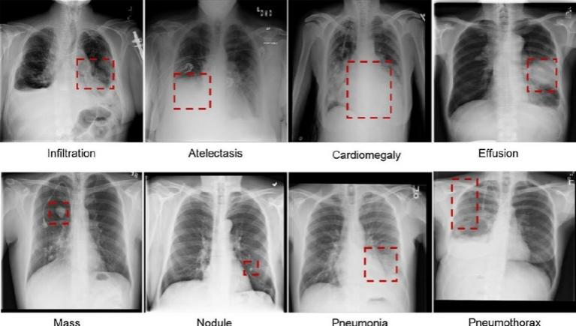

Picture 1 Example of usable dataset

Artificial intelligence technology research and development activities require more complex architectures with non-single computational loads. Artificial intelligence systems that lead to exploration of broad solution spaces with long time predictions require dynamic simulation models that often use agent-based approaches with tens to thousands of agents. This agent must perform millions of iterations in a short time to produce useful predictive conclusions.

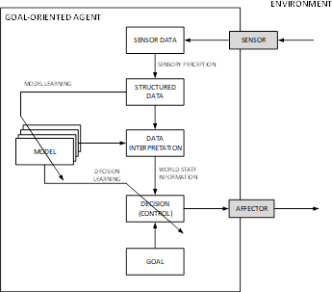

Picture 1 Research Framework

The picture above shows that information from the environment is observed and extracted by Sensory Perception from random form to Structured Data form. The information is also structured to describe the relationship between the data components. Furthermore, the Structured Data is then interpreted according to the context represented by the chosen AI Model to describe the state of the system where the system must react to the stimulus in order to achieve its goals.

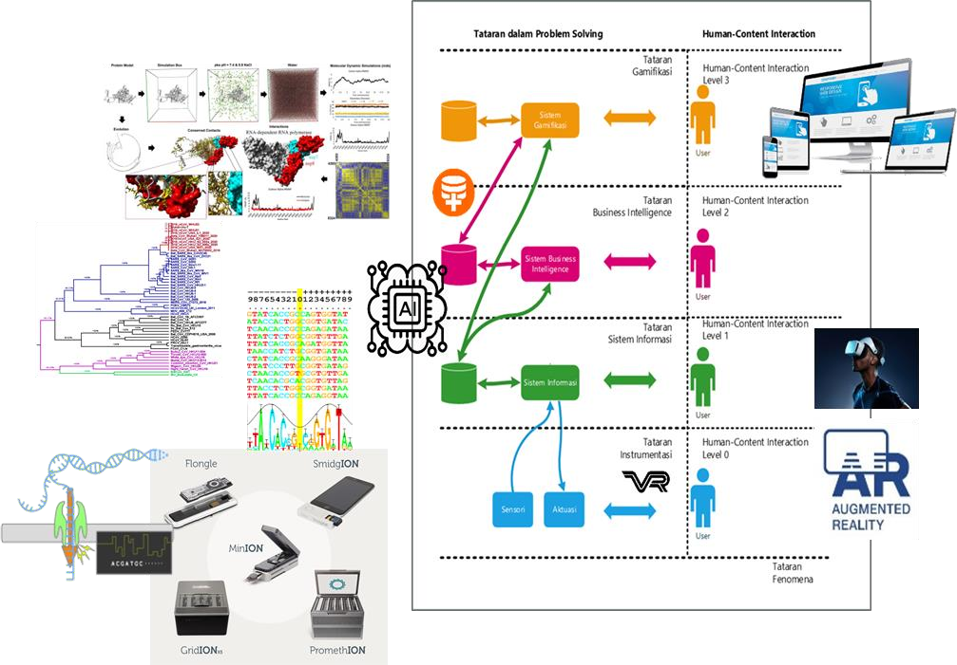

Picture 2 Application Layer of Smart Health Care Service

In the Figure above, the Full-Stack Artificial Intelligence System is built from 4 application layers. Instrumentation Application Level, which is when information from the real world is digitized. At this level, x-ray images resulting from exposure to x-rays that penetrate the human chest suspected of being affected by Covid-19 will be scanned and formed in the form of an image file.

Information System Application Level, namely when information from the instrumentation application level is not only used in a momentary situation but is collected in a structured and systematic manner in the time domain (historical) as well as in the spatial domain so that it can be displayed or processed in a richer and more meaningful way for users. At this level, the radiologist will use the website that has been built on a regular basis so as to provide data input that can enrich information to develop the knowledge that has been previously owned.

Business Intelligence System Application Level, namely when information obtained from the information system application level is managed on a more massive scale to get a richer, more diverse and deeper picture and insight than can be obtained at the information system application order scale so that it can help users to make more informed decisions. This level usually involves processing massive amounts of data (Big-Data), the use of more explicit mathematical models and modeling concepts (Modeling & Simulation) and the use of sophisticated Machine Learning algorithms. If the system already has the correct initial knowledge about the classification of Covid-19 disease from x-ray images, then these trained algorithms will be massively retrained by tera bytes of big data.

Gamification System Application Level, namely when all the metadata values that can be inferred from the Business Intelligence System application level are managed and processed by engineering the behavior of system users so that the system achieves certain KPIs. At this stage, users, especially radiologists, will feel the benefits of the system that has been built, which has provided true suggestions for the diagnosis of Covid-19 disease with x-ray images. After that, they will feel that it is better to use this built-in artificial intelligence than to spend a long time analyzing x-ray images. Not to mention, it has been recognized that the reading of x-ray images in each radiologist will be different, due to factors of knowledge, experience, mental and eye fatigue, age factors or other factors that cannot be identified one by one.

In developing an intelligence algorithm where the ultimate goal is to get the best knowledge that can be carried out by the system, the following steps will be carried out in research:

In the first stage, radiologists working with researchers will fill in data through the website http://x-ray.pptik.id/#/app/dashboard. This data will enrich existing big data and then be divided into training data, development data and datasets.

Then these data will be predefined, namely changing the data size to 224x224 pixels. Data augmentation. Data augmentation aims to add variety to data by applying transformations to image data. In this study, the transformation used is horizontal flip only. Augmentation data is only applied to training data. Preprocessing input function. Then apply a function that processes data according to the input pretrained model when trained on the dataset. Furthermore, it produces a data balance that is ready for training by 60 percent, 20 percent for development data for cross validation and a data set of 20 percent. This processing stage will continue to develop the previously formed epoch.

To increase the accuracy value, Adam's Optimization is used. Furthermore, an evaluation of the performance of the algorithm is carried out in the form of the relationship between accuracy and GPU operations. If the error resulting from the optimization performance is still greater than 5 percent, then the iteration is carried out again or another CNN block is added to produce a block with efficient performance.

The following is a description of the algorithm steps formed.

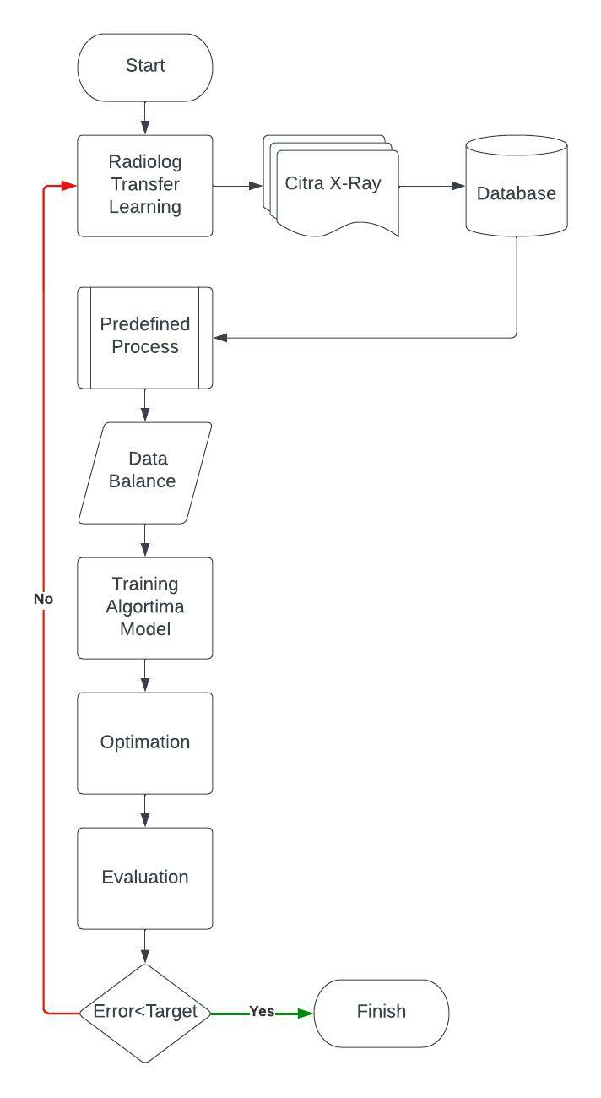

Picture 3 Flowchart Algorithm

**DISCUSSION**

In this study, the authors used the ResNet and VGG algorithms with loss function Binary Cross Entropy with Logits and standard metrics Accuracy, Precision, Recall, and F1 Score In this study, the authors used the ResNet and VGG algorithms with loss function Binary Cross Entropy with Logits and standard metrics Accuracy, Precision, Recall, and F1 Score to assess model performance. Data composition and performance validation scores for each model can be seen in the following tables

TABLE 2 VALIDATION DATASET

|  |  |  |
| --- | --- | --- |
| **Data set** | **Train** | **Validation** |
| StonyBrook University | positive: 1898 | positive: 475 |
| Khulna University | positive: 1220  negative: 1747 | positive: 305  negative: 437 |
| Covid Chestxray | positive: 381  negative: 242 | positive: 96  negative: 60 |
| NIH | negative: 1511 | negative: 378 |
| **Total** | **positive: 3500**  **negative: 3500** | **positive: 875**  **negative: 875** |

The selection of data is selected based on positive data first due to the uncertainty of negative data in several data sets. When no specific disease label is found in an image of the lungs, it is not certain that the disease does not exist in the image. This is because there is data that has not labeled the disease.

The following are the results of the training algorithm that we tested.

TABLE 3 ALGORITHM RESULT

|  |  |  |  |  |
| --- | --- | --- | --- | --- |
| **Arsitektur Model** | **Validation Score** | | | |
| **Accuracy** | **Precision** | **Recall** | **F1 Score** |
| ResNet50 | 87.03 | 85.06 | 89.83 | 87.38 |
| ResNet101 | 89.54 | 86.65 | 93.49 | 89.94 |
| VGG19 | 93.26 | 92.96 | 93.6 | 93.28 |

The results show that the VGG19 algorithm from this training produces better accuracy values than Resnet50 and Resnet101. This is possible because VGG has a large epoch value compared to Resenet. However, in terms of computation time, VGG takes more time than Resnet. This is because in resnet, there are many residual values that are fed back for the next epoch.

If without a "skip-connection", the output value from the resnet is denoted as H(x) with the equation: H(x)=f(wx + b). With the "skip-connection" layer, the output value becomes H(x)=f(x)+x. The amount of residual x from the previous looping epoch becomes a significant weighting of the input value for the next. This will cause differences in the dimensions of the input output.

To overcome problems that arise due to dimensional differences between input and output caused by layer pooling mechanisms, one of the following two approaches is carried out by adding dimensions, zero padding to the "skip-connection" or a 1x1 convolution layer added to the input to adjust the dimensions . If the second approach is chosen.

Convolutional neural network is an artificial neural network used in deep learning to evaluate visual information. The constituent structure can be explained through the following figure.

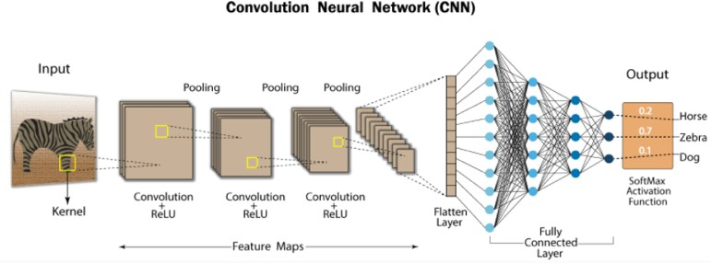

Picture 4 Structure of CNN

As shown in the image above, CNN consists of input layers, output layers, many hidden layers, and millions of parameters that allow it to "learn" complex patterns and objects. It uses convolution and pooling processes to sample the input before applying the activation function, which as a whole is a hidden layer so in this processing GPU, we can applied so much layer for the best accuracy result.

In CNN, the main building element is the onvolution layer which consists of input vectors derived from images, filters which are feature detectors, and output vectors which are feature maps. The image is abstracted onto a feature map, which is also known as an activation map after passing through the convolution layer. Input that has been convolved from one convolution layer will be passed as output from the previous layer to the next layer.

This mechanism is analogous to the response of neurons to a single stimulus in the visual cortex. Each neuron in the convolution layer only processes data for the receptive field assigned to it, this characteristic makes connectivity on CNN local. This is the main principle of CNN, namely local connectivity, and parameters (weight and bias) that are of the same value on all neurons (parameter sharing).

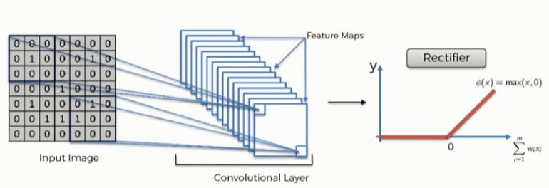With local connectivity, each neuron is only connected to a part of the input image vector, thereby reducing the number of parameters and is expected to speed up calculations.

Picture 5 Convolutional Process in CNN

Padding is added to the image frame to help the kernel cover the entire image matrix during the convolution process. Stride indicates the number of pixels shifted from the kernel when convoluted to the image matrix. If the stride is set to one, then the kernel will shift one pixel in each convolution process. Pooling also added to prevents overfitting. If there is no pooling mechanism, the output resolution will be the same as the input.

**CONCLUSION**

A lung disease diagnostic tool system has been successfully developed in this study and embedded on smart health care with application layer method. Based on the results of a comparison of the three deep learning architectures, VGG19 provides better accuracy, precision, recall, and F1 core results when compared to ResNet50 and ResNet101.

**BIBLIOGRAPHY**

Andika, L.A., Pratiwi, H. and Handajani, S.S. (2019) ‘Klasifikasi Penyakit Pneumonia Menggunakan Metode Convolutional Neural Network Dengan Optimasi Adaptive Momentum’, *Indonesian Journal of Statistics and Its Applications*, 3(3), pp. 331–340. https://doi.org/10.29244/ijsa.v3i3.560.

Cohen, J.P. *et al.* (2021) ‘TorchXRayVision: A library of chest X-ray datasets and models’. Available at: http://arxiv.org/abs/2111.00595.

Images, X. (2021) ‘COVID-19 Detection Using Deep Learning Algorithm on Chest X-ray Images’.

Khan, S.H. *et al.* (2022) ‘COVID-19 Detection in Chest X-ray Images Using a New Channel Boosted CNN’, *Diagnostics*, 12(2). https://doi.org/10.3390/diagnostics12020267.

Oh, Y., Park, S. and Ye, J.C. (no date) ‘Deep Learning COVID-19 Features on CXR using Limited Training Data Sets’, pp. 1–13.

Ozturk, T. *et al.* (2020) ‘Automated detection of COVID-19 cases using deep neural networks with X-ray images’, *Computers in Biology and Medicine*, 121(April), p. 103792. https://doi.org/10.1016/j.compbiomed.2020.103792.

Prastyowati, A. (2020) ‘Mengenal Karakteristik Virus SARS-CoV-2 Penyebab Penyakit COVID-19 Sebagai Dasar Upaya Untuk Pengembangan Obat Antivirus Dan Vaksin’, *BioTrends*, 11(1), pp. 1–10.

Quan, H. *et al.* (2020) ‘COVIDiagnosis-Net: Deep Bayes-SqueezeNet based diagnosis of the coronavirus disease 2019 (COVID-19) from X-ray images’, *Computers in Biology and Medicine*, 121(April), pp. 132665–132676. https://doi.org/10.1016/j.cmpb.2020.105581.

Quan, H. *et al.* (2021) ‘DenseCapsNet : Detection of COVID-19 from X-ray images using a capsule’, *Computers in Biology and Medicine*, 133(April), p. 104399. https://doi.org/10.1016/j.compbiomed.2021.104399.